# Keyman Keyboard Usage Instructions

Please make sure that Keyman is already running in your machine. This can be seen my the small keyboard key-like icon in the taskbar.



In some cases, the icon could be hidden as shown below;

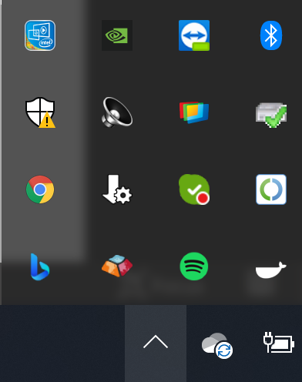

If you cannot see the icon, please start Keyman.

With Keyman running, you should be able to see the Aazhvaar Telugu keyboard by clicking on the language icon (that most probably says ENG).

Open your favorite word processor and set the font as Aazhvaar Telugu.

Using the language menu as shown above, set the Keyboard to “Aazhvaar Telugu Phonetic”. You can also invoke the language menu using windows key + space bar.



You can now compose text. Make sure the font is properly set as Aazhvaar Telugu.

If the font switches back and the characters appear garbled, reselect the text and assign the proper font again.

They keyboard mapping can be found under the start menu within the folder "Aazhvaar Telugu Phonetic".

